Module | WSQ- Business Analytics (SF)
Name | Koh Chun yao
Date | 14 Feb 2026

Assignment-2b Submission

Task 1 - CREATE MODEL RELATIONSHIPS

Provide screenshot of semantic model, verify that you have all the tables and their interrelationships in the screenshot:

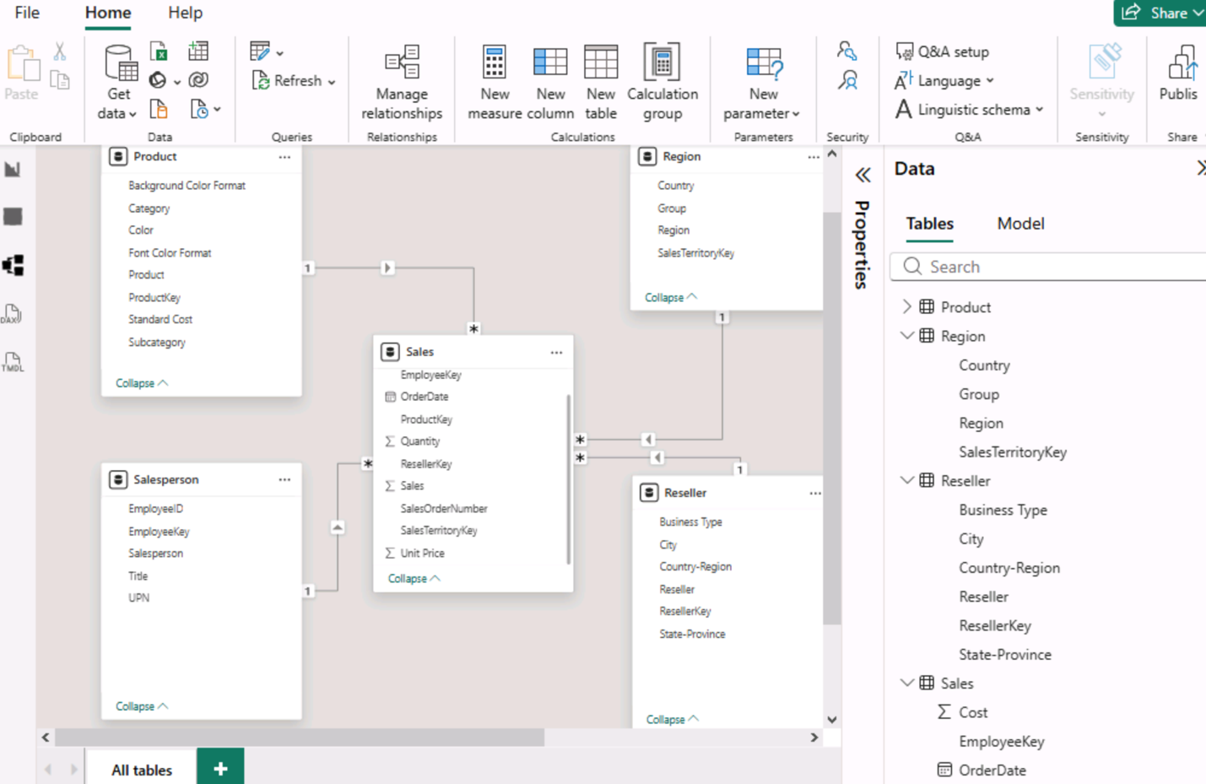

Task 2 - EXPLORE THE MODEL INTERFACE

Provide the Screenshot of Report view Data pane, with columns and hierarchies

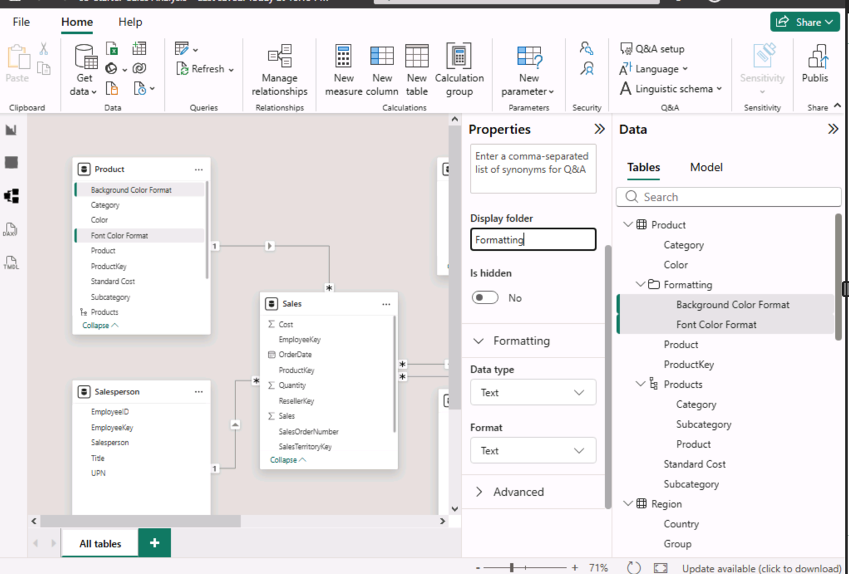

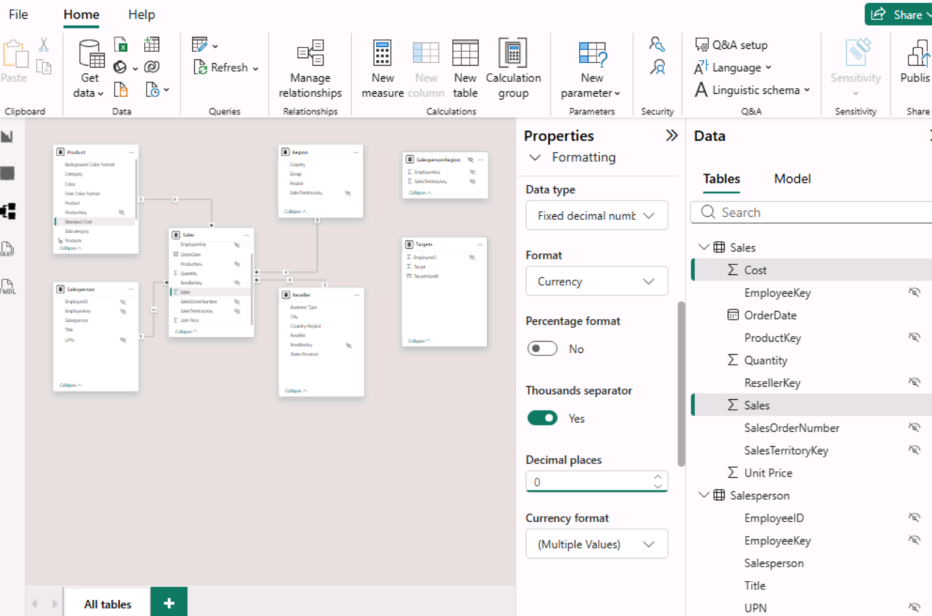

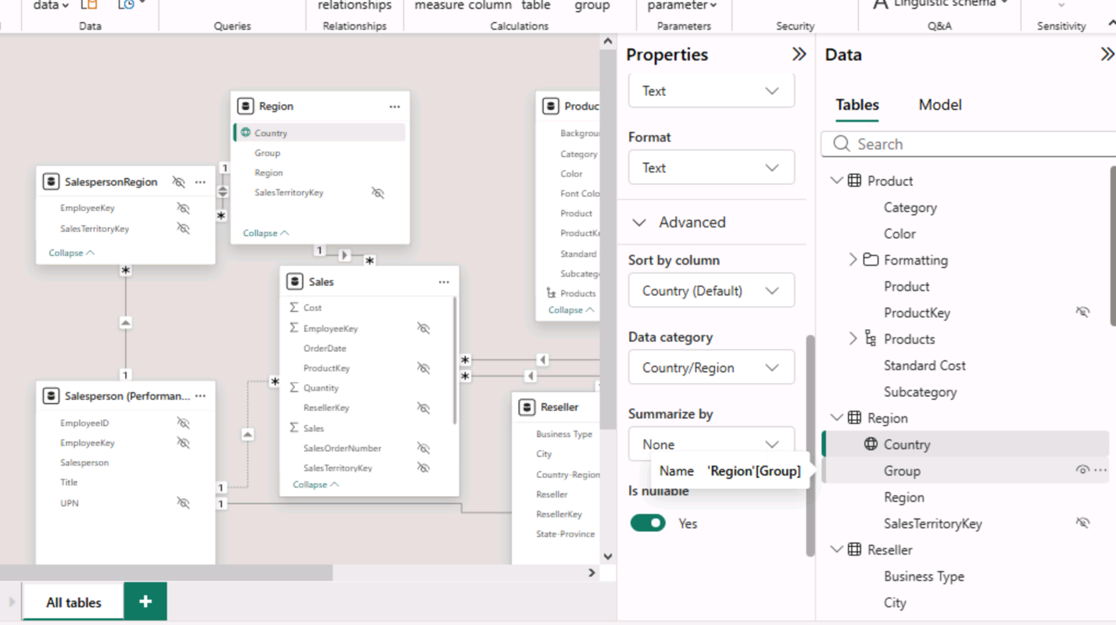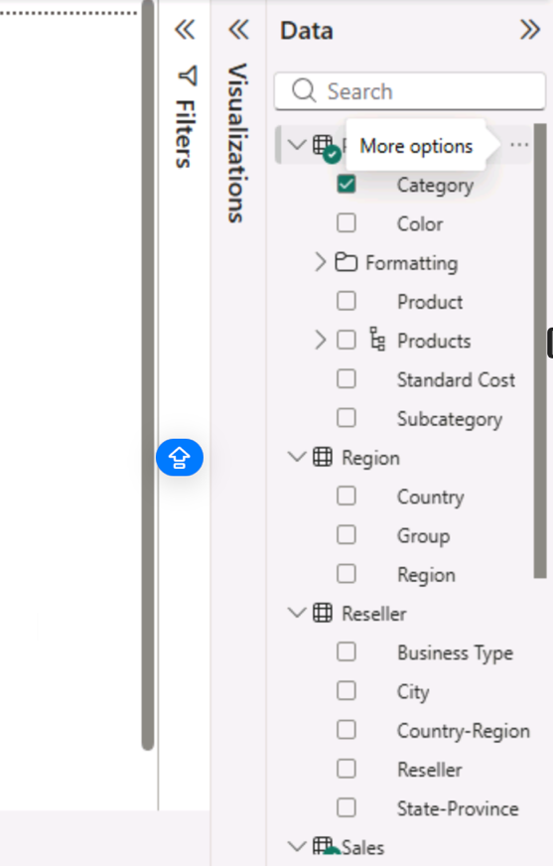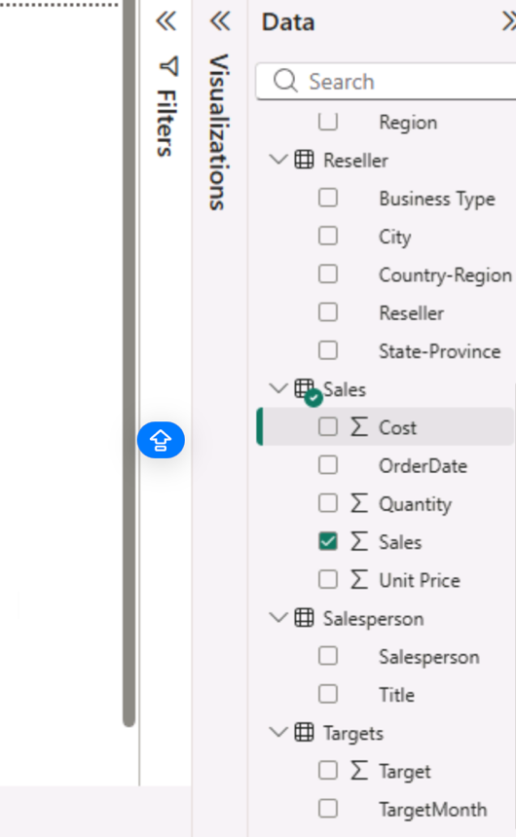

Task 3 - CREATE QUICK MEASURES

Provide the Screenshot of Created Measures Profit and Profit Margin in Data pane

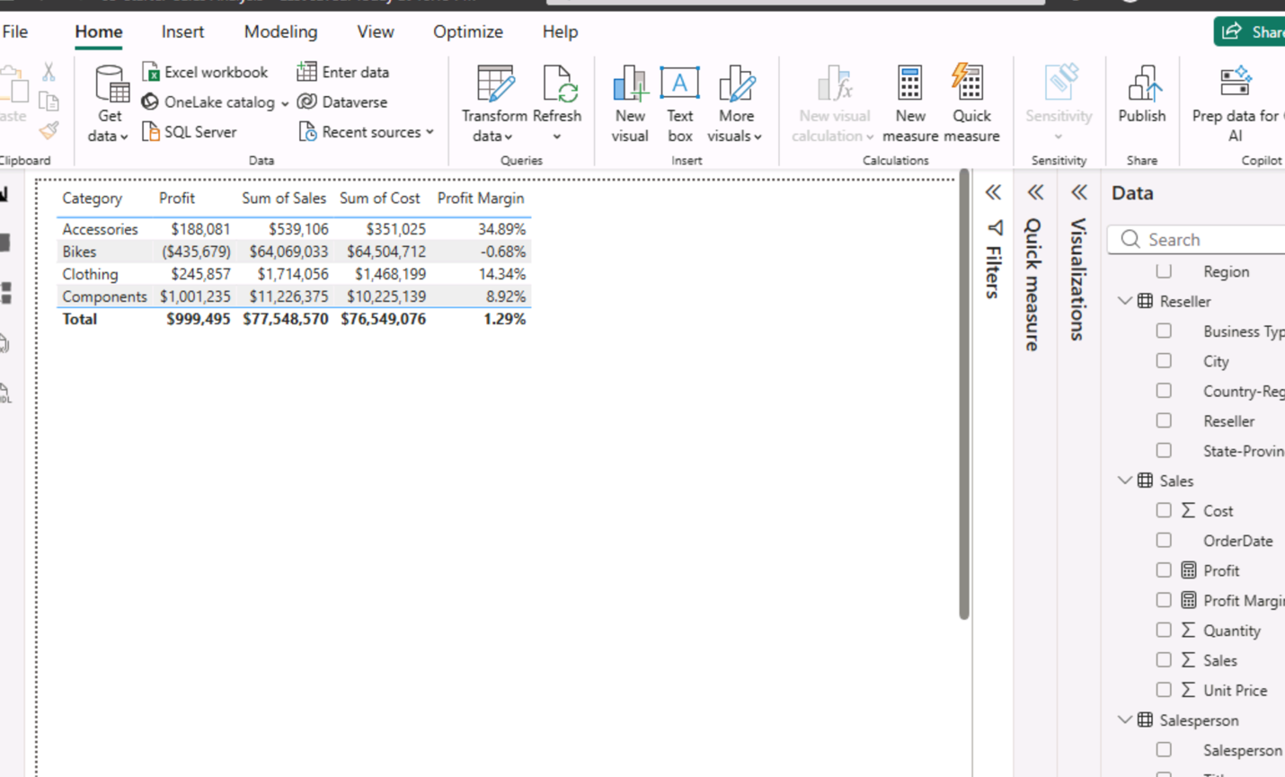

Task 4 - CREATE A MANY-TO-MANY RELATIONSHIP

Provide the Screenshot of model diagram in model view